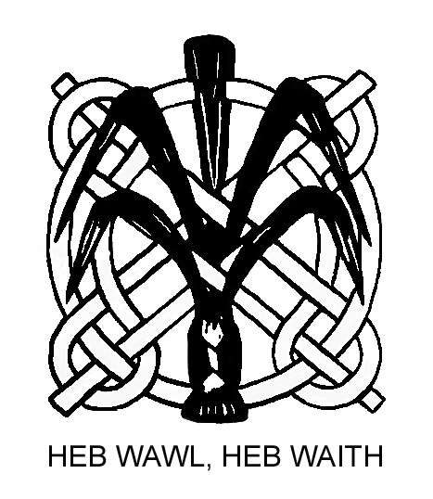

THE WELSH PHOTOGRAPHIC FEDERATION

UNDEB FFOTOGRAFFIAETH CYMRU
Member of FIAP and the Photographic Alliance of Great Britain

ACE OF CLUBS COMPETITION 2019

Club/Society .........................................................................................................

Contact name and telephone number ………………………………………………

MASTER LIST – Second Page 21- 40
Image  Number | Unique Code | Photographer | Title | Marks
121

122

123

124

125

126

127

128

129

130

131

132

133

134

135

136
137
138
139
140

