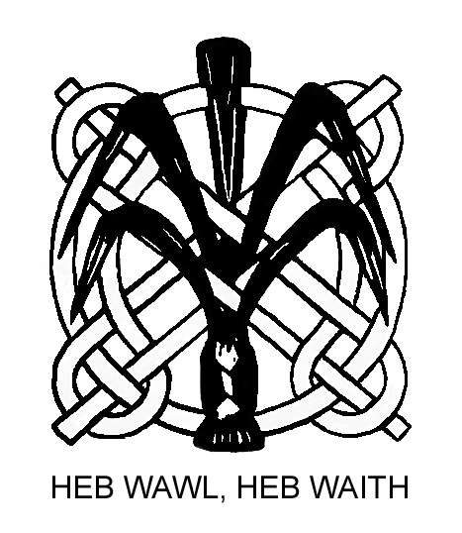

THE WELSH PHOTOGRAPHIC FEDERATION

UNDEB FFOTOGRAFFIAETH CYMRU
Member of FIAP and the Photographic Alliance of Great Britain

ACE OF CLUBS COMPETITION 2019

Club/Society .........................................................................................................

MASTER LIST – First Page 1- 20

Image  Number | Unique Code | Photographer | Title | Marks
101

102

103

104

105

106

107

108

109

110

111

112

113

114

115

116
117
118
119
120

